Audition Monologues:

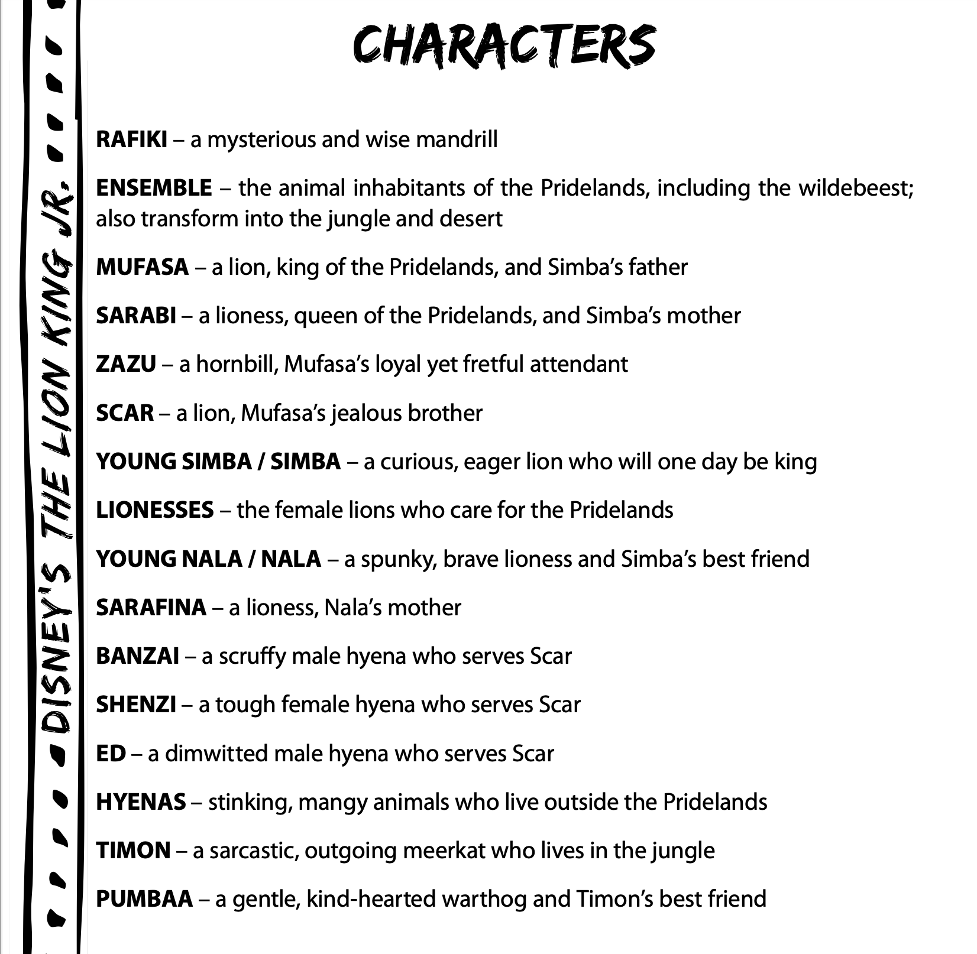

RAFIKI

Ha, ha. You won’t find him here. The King has returned!

MUFASA
A king’s time as ruler rises and falls like the sun. One day, Simba, the sun will set on my time here and will rise with you as the new king.
You see, Simba, everything exists in a delicate balance. As king, you need to understand that balance and respect all creatures − from the crawling ant to the leaping antelope.
SCAR
Well, I got the lion’s share of brains... but when it comes to brute strength, I’m afraid I’m in the shallow end of the gene pool...
Oh, no, Mufasa. Perhaps you shouldn’t turn your back on me!
ZAZU
Step lively! The sooner we get to the waterhole, the sooner we can leave! Oh, just look! Little seeds of romance blossoming in the savanna! And one day you two will be married! Sorry to burst your bubble, but you two turtle doves have no choice. It’s a tradition going back generations.
(realizing the cubs are gone
Simba?... Nala? Where are you hiding?! If you don’t come out this instant― This isn’t funny. I’m not laughing.
YOUNG SIMBA
Hey, Uncle Scar! Guess what? I’m gonna be king of Pride Rock! My dad just showed me the whole kingdom! And I’m gonna rule it all!
SARABI
Scar, there is no food. The herds have moved on. We must leave Pride Rock. You are sentencing us to death.
NALA
Simba, I don’t understand. You’ve been alive all this time. Why didn’t you come back to Pride Rock? Simba, Scar let the hyenas take over the Pridelands!
SIMBA
Hakuna matata. It’s something I learned out here. Look, sometimes bad things happen and there’s nothing you can do about it. So why worry?
SIMBA
She’s wrong. I can’t go back. What would it prove, anyway? It won’t change anything.
TIMON
Whoa, whoa, whoa! Time out! Let me get this straight. You know her. She knows you. But she wants to eat us. And everybody’s okay with this?!?
PUMBAA
Aw, Timon – look at him. He’s so cute and all alone. Can we keep him?
YOUNG NALA
It’s really creepy. We could get in big trouble!
YOUNG NALA
Hey, genius − it was my idea!

