Welcome to PSMS Chorus/ Music Theatre
We are so thrilled that you’ve decided to participate in the PSMS Chorus/ Music Theatre Program! We have many fun and exciting things planned for our department this year. Please see below for details and mark your calendars for future events. Feel free to email me with any questions or concerns at afrancis@pcsstn.com. You may also visit prescottchorus.com for more detailed information regarding the events below.
Sincerely,
Ms. Francis and the Production Team of Newsies

Chorus/ Music Theater Newsletter
  - Prescott South Middle School
  - 2023-2024
PSMS Parent Open House/ Back to School Night:
August 8th
5:30 - 7pm; PSMS Auditorium
***This event is not required.

Newsies Auditions Coming Soon!
Auditions:
Monday, August 7th 3-5pm
Tuesday, August 8th 3-5pm
Thursday, August 10th 3-5pm
Friday, August 11th 3-5pm

Call Backs:
Saturday, August 12th
10am – 12pm

First Rehearsal:
August 15th 3-5pm

Parent Meeting:
August 15th 5-5:30pm
PRESENTED BY PSMS MUSICAL THEATRE

More information regarding Newsies Auditions, Audition Forms, Rehearsal Schedules, etc. can be found at prescottchorus.com.

This year at a glance:
Each year, the PSMS Chorus performs in a variety of concerts and programs. We also take numerous field trips throughout the year in order for students to broaden their musical horizons. Below you will find a brief outline of Fall events!
Country Music Hall of Fame Field Trip:
(Taylor Swift song writing experience)
All day event in Nashville, TN
Cost: $10-15 Date: TBD

Newsies Auditions:
August 7th, 8th, 10th, and 11th 3-5pm
Call Backs: August 12th 10am – 12pm
Parent Meeting/ First Rehearsal: August 15th
Putnam County Choir Festival:
Tuesday, October 24th
PSMS Auditorium; All Day Event
7th/8th Graders Only by Audition
***This event is encouraged but not required.

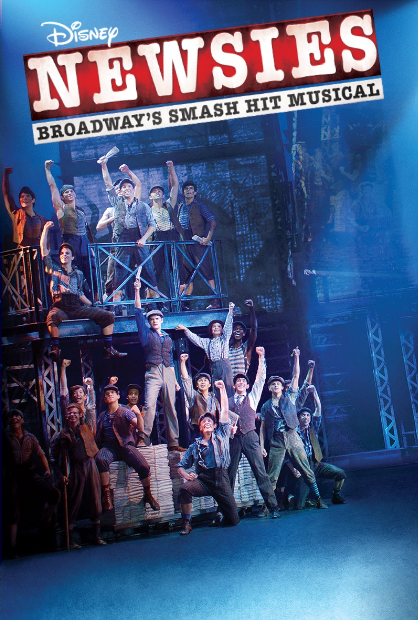
Veterans Day Performance:
Friday, November 10th
8:30am; PSMS Auditorium
***Required for all chorus students
Winter Chorus Concert:
Tuesday, December 5th
6pm; PSMS Auditorium
***Required for all chorus students

2023-2024 Field Trip Outline/ Details:
Country Music Hall of Fame
The 6th – 8th grade chorus will travel to spend a day at the Country Music Hall of Fame in Nashville, TN. This field trip is being scheduled as we speak for the end of August. Tickets usually range between $7-10. More details coming soon.
Cookeville Children’s Theatre Performances
The PSMS Chorus travels each November to view a musical performance presented by the Cookeville Children’s Theatre at the Cookeville Performing Arts Center.
Tickets are typically $5.
Caroling
Each December, the chorus travels to the surrounding Elementary Schools to go Caroling and lead students in a fun Christmas sing along.
Cookeville High School Performance
Each Spring, the PSMS Chorus travels to CHS to view their musical.
Tickets are typically $7.
8th Grade Field Trip
Each May the 8th grade chorus students take an end of the year field trip to Dollywood! Tickets range from $40-55. Family members welcome. Start saving up now!

